TRANSFER OF REHABILITATIVE CARE PILOT
Health Service Provider – TRC Form Tracking Log
To be used by Health Service Provider sit champions to track feedback on TRC form throughout
 | Section within TRC Form | Issues/Opportunities for Improvement
 |  | Whole section  (specify if the whole section needs to be reviewed) | Data Fields  (Specify exact data fields) | Suggested improvements  (Remove, edit, or add additional information to the related data fields/sections in the form, please specify)
1 | 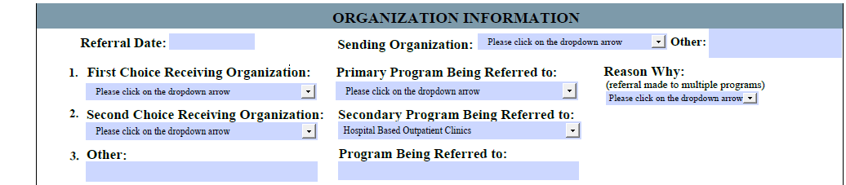
2 | 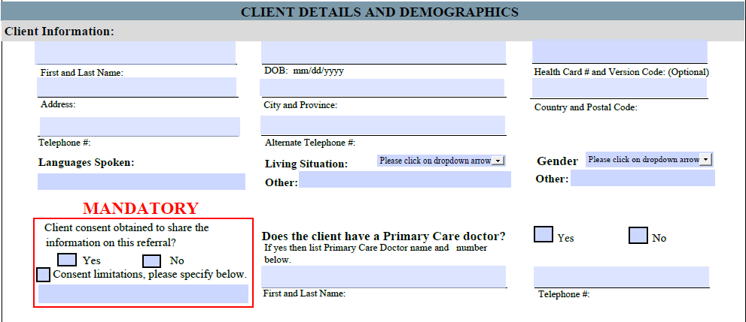
3 | 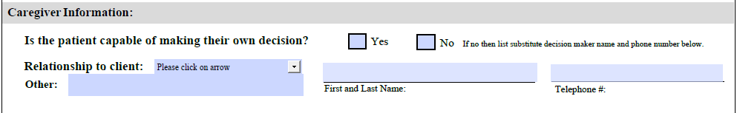
4 | 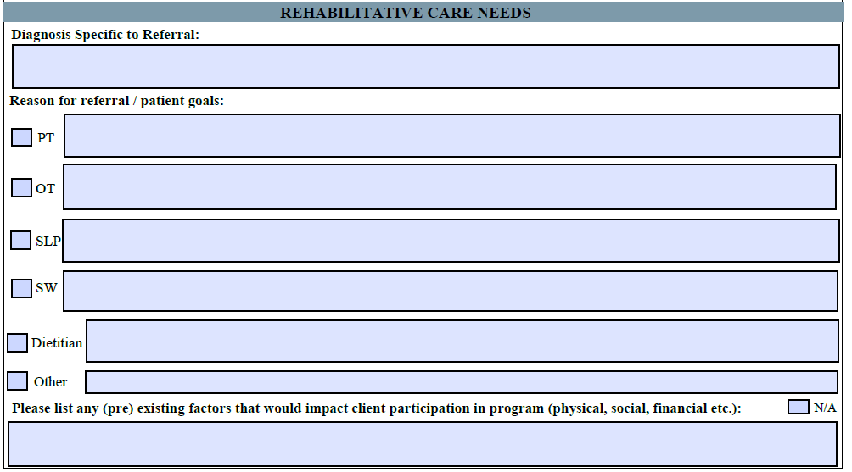
5 | 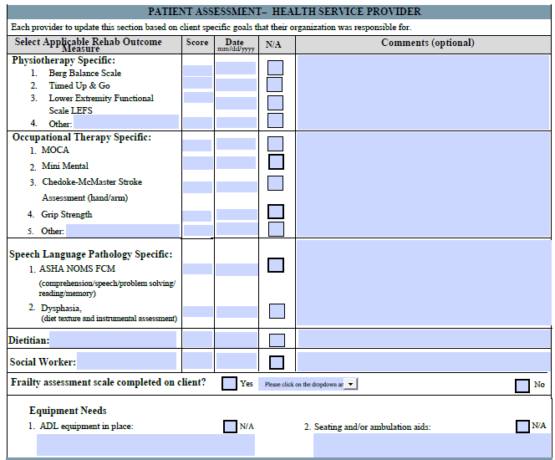
6 | 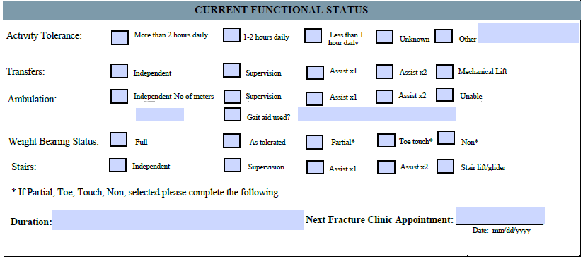
7 | 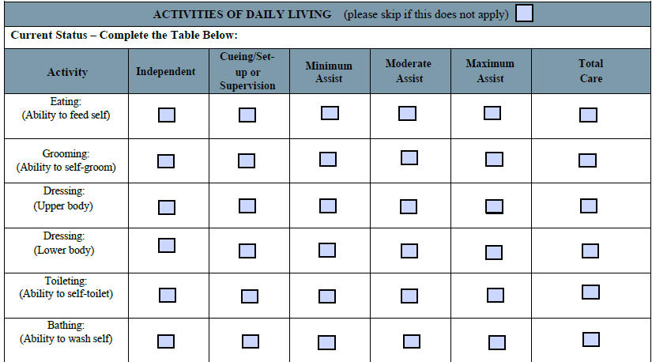
8 | 
9 | 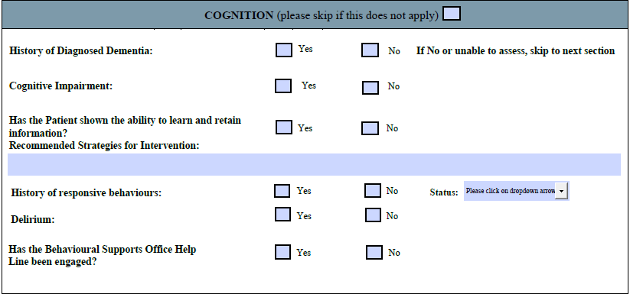
10 | 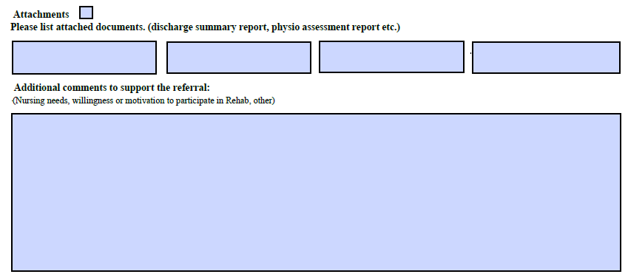
11 | 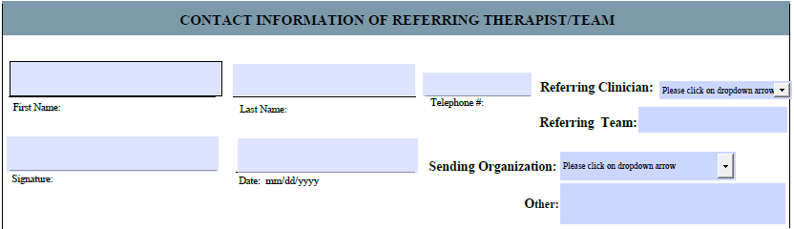
12 | 